E- Nomination filling procedure on EPF website for all BSNL recruited employees

STEPS

1.) OPEN THIS LINK ON WEB BROWSER

https://unifiedportal-mem.epfindia.gov.in/memberinterface/

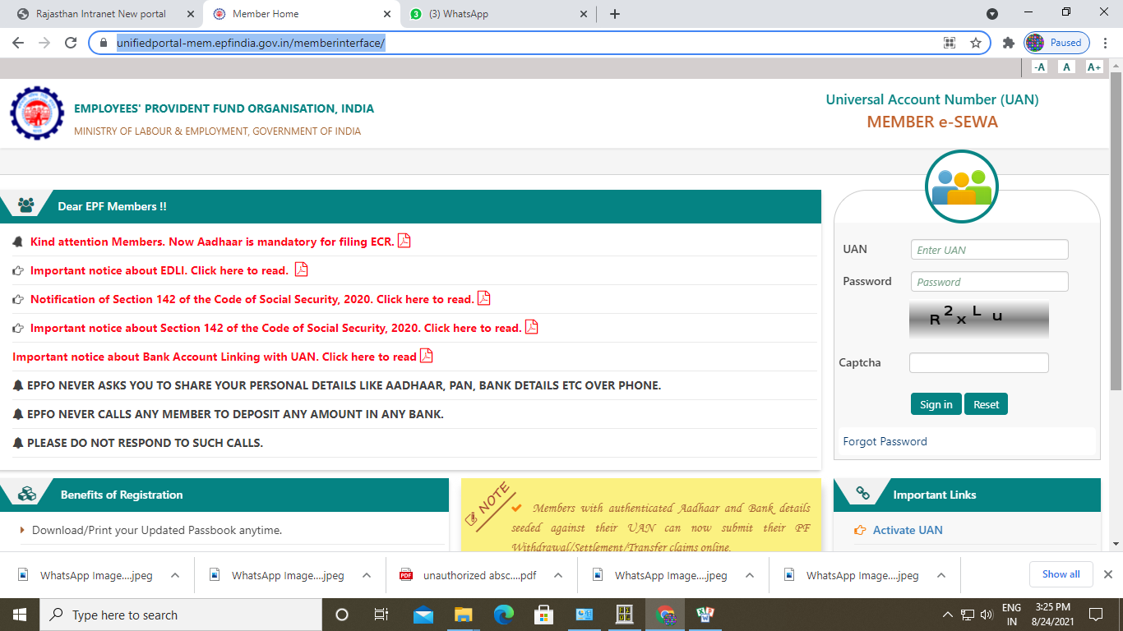

2.) Please sign in by enter your UAN No and Password along with Captcha

3.) This screen will open
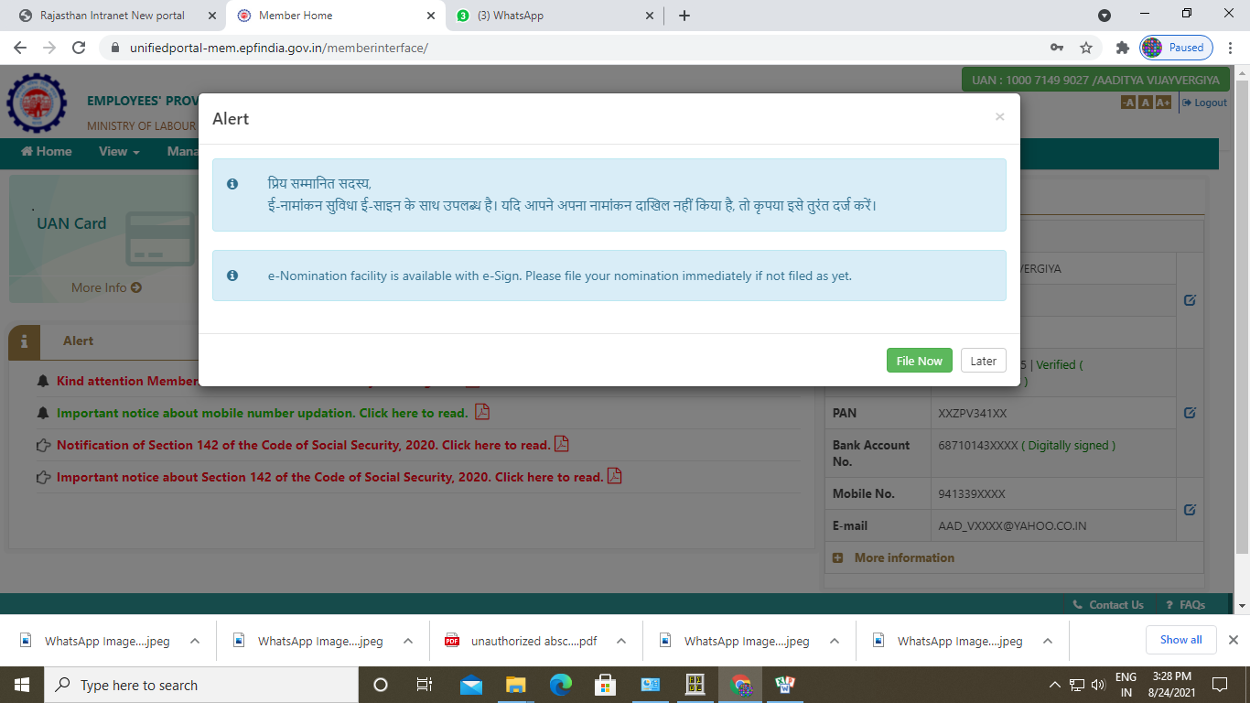

4.) Click on File now,
5.) Then click View → PROFILE

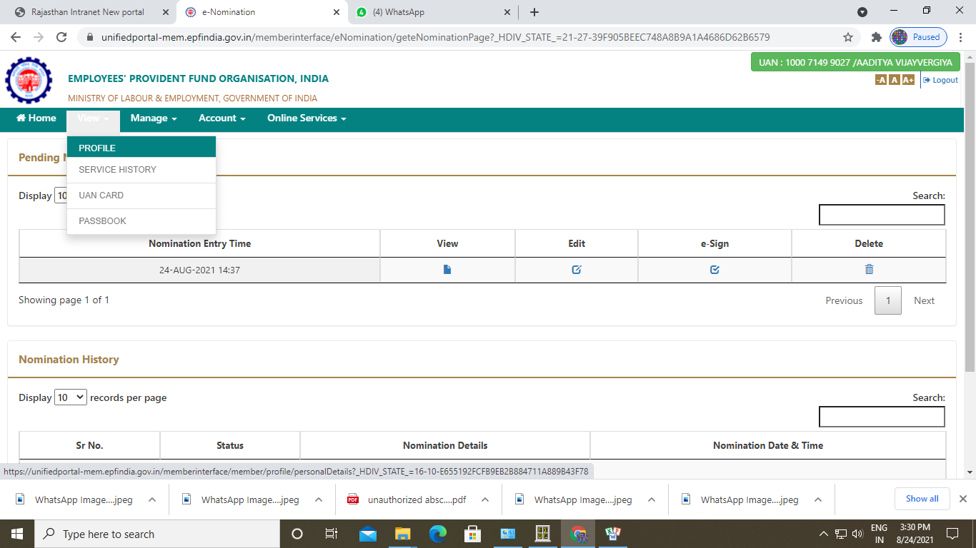

6.) UPLOAD your passport size photo (size less than 100 Kb) AND also Edit missing details if any (like Qualification detail/ Marital status / Address)

7.) Then go to Manage → E-NOMINATION

It will ask

Having Family
click YES

Now click
Add family Detail

pls enter your Nominee Detail as

Aadhar No. / Name / Gender / Relationship / Address / Bank account Detail / Photo (less then 100 Kb size)

save family detail

Now CLICK check box for EPF nomination
and enter 100 in share % column ( only If u want single nominee , otherwise add all members first one by one and then fill % share as per your wish among all nominees)

then CLICK save EPF nomination

Now again go to

Manage → E-NOMINATION

One row will show, it will have a word written e sign
click for this e sign tab

when u click on E-sign link , it will take u on another link as below
to update esign click for this link in web browser

https://resident.uidai.gov.in/vid-generation

Here u first generate virtual ID against your Aadhar number

By entering -> your Aadhar number
and generating OTP , fill OTP and
fill Captcha in given box

A SMS will come for a 16 digit virtual ID, enter the same there; it will complete your e sign work.
Finally your E- nomination updating work is complete now.

Please again go to

Manage → E-NOMINATION

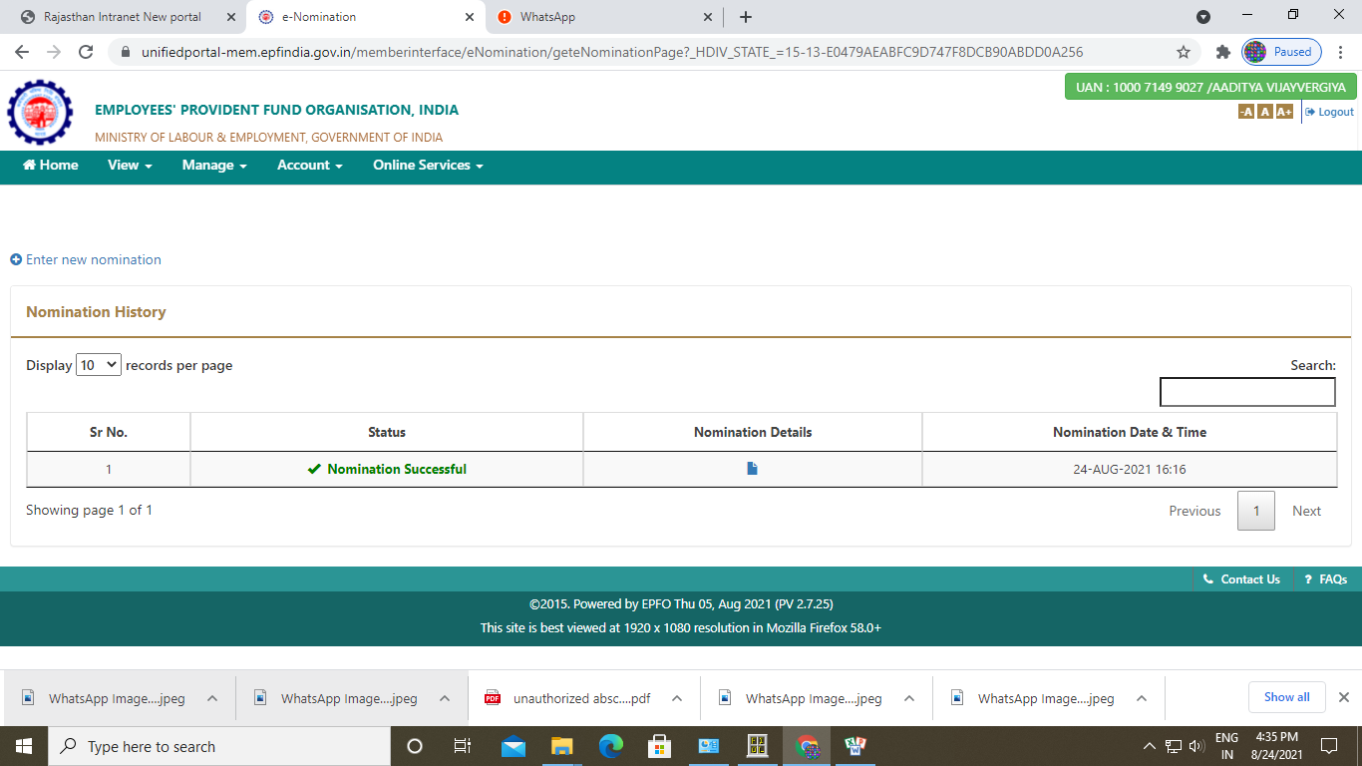
If u see Nomination Successful in green color means

You have successfully updated all detail corresponding to Nominee.

Have a good time.
Thanks!

TEAM AIGETOA

